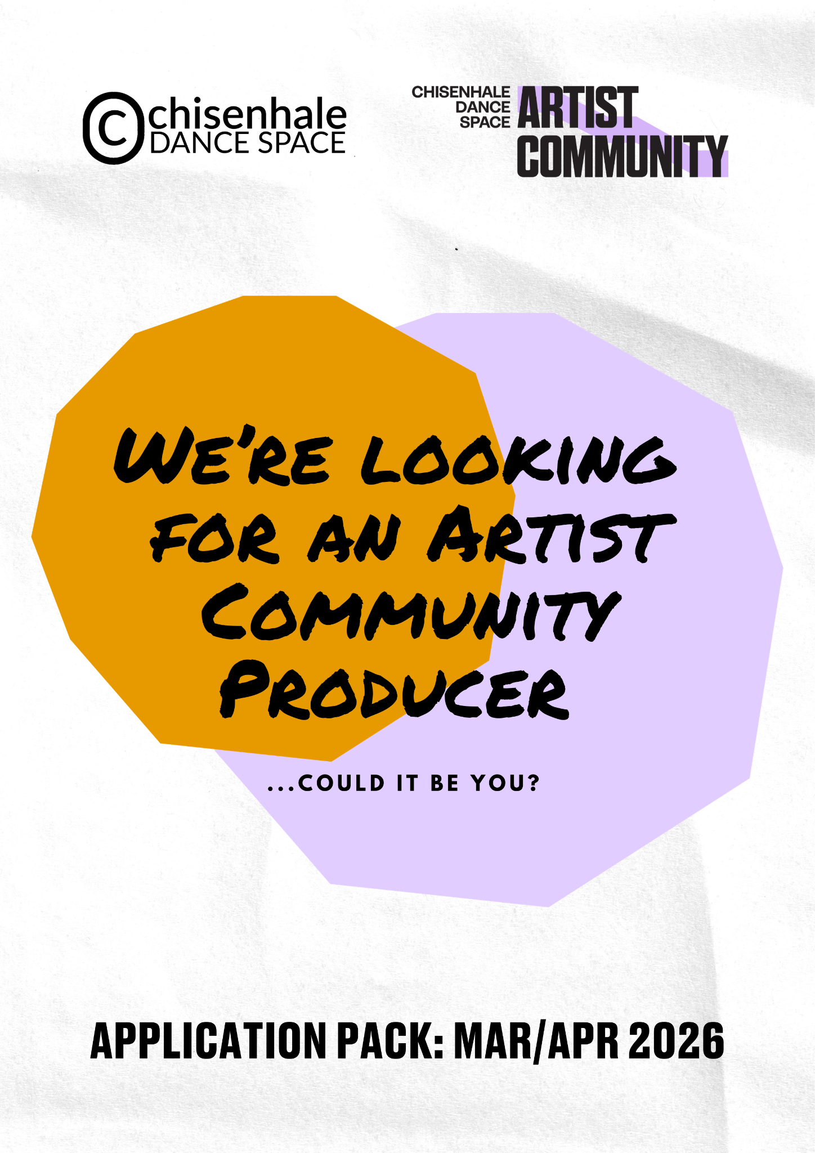

Background

The organisation

Chisenhale Dance Space (CDS) has been making space for artists to lead, experiment, and create for over 40 years, serving marginalised dance artists from Tower Hamlets, London, and across the UK. We support an Artist Community that spans all ages and roles within experimental performance, including performers, choreographers, teachers, curators, producers and advocates for sectoral change. We prioritise the needs of those who have been historically marginalised, including artists of Global Majority heritage and disabled/neurodivergent artists. Our programmes are artist-led, centred on the belief that artists best understand their needs and are key drivers of change in the sector. We offer a responsive framework of opportunities and peer support tailored to the challenges artists face.

Our main activity and impact strands are:

- Community Building: We are committed to being ‘choreographers of community,’ bringing artists together and providing vital networking and development opportunities to create a more connected, creative, and caring sector.
- Access to Affordable Space: We believe all artists should have
access to safe, affordable, and easily bookable spaces. We are committed to
being London’s most affordable studio space and wanting artists to feel at home, both physically and spiritually, with us.

- Artist Support: Being an artist is more challenging than ever, with limited opportunities. We pride ourselves on supporting artists in our community and beyond, especially those marginalised, by enabling projects that might not be possible elsewhere. Committed to sharing resources and knowledge, we see ourselves as the glue supporting artists when they have less institutional backing.

- Influence, Advocate, and Changemake: We seek to drive positive change in the dance and performance sector by promoting transparent, ethical, and inclusive practices - with a particular focus on anti-racist and anti-ableist practice. Through advocacy, innovative methods, and thought leadership, we aim to empower artists to embed these principles in their work and influence broader sectoral shifts.

CDS is one of three independent charities at Chisenhale Art Place, a former veneer factory on Chisenhale Road, alongside Chisenhale Gallery and Chisenhale Studios. Our location, which was central to the ‘New Dance’ movement of the 1980s and 1990s, continues to influence our identity and programming.
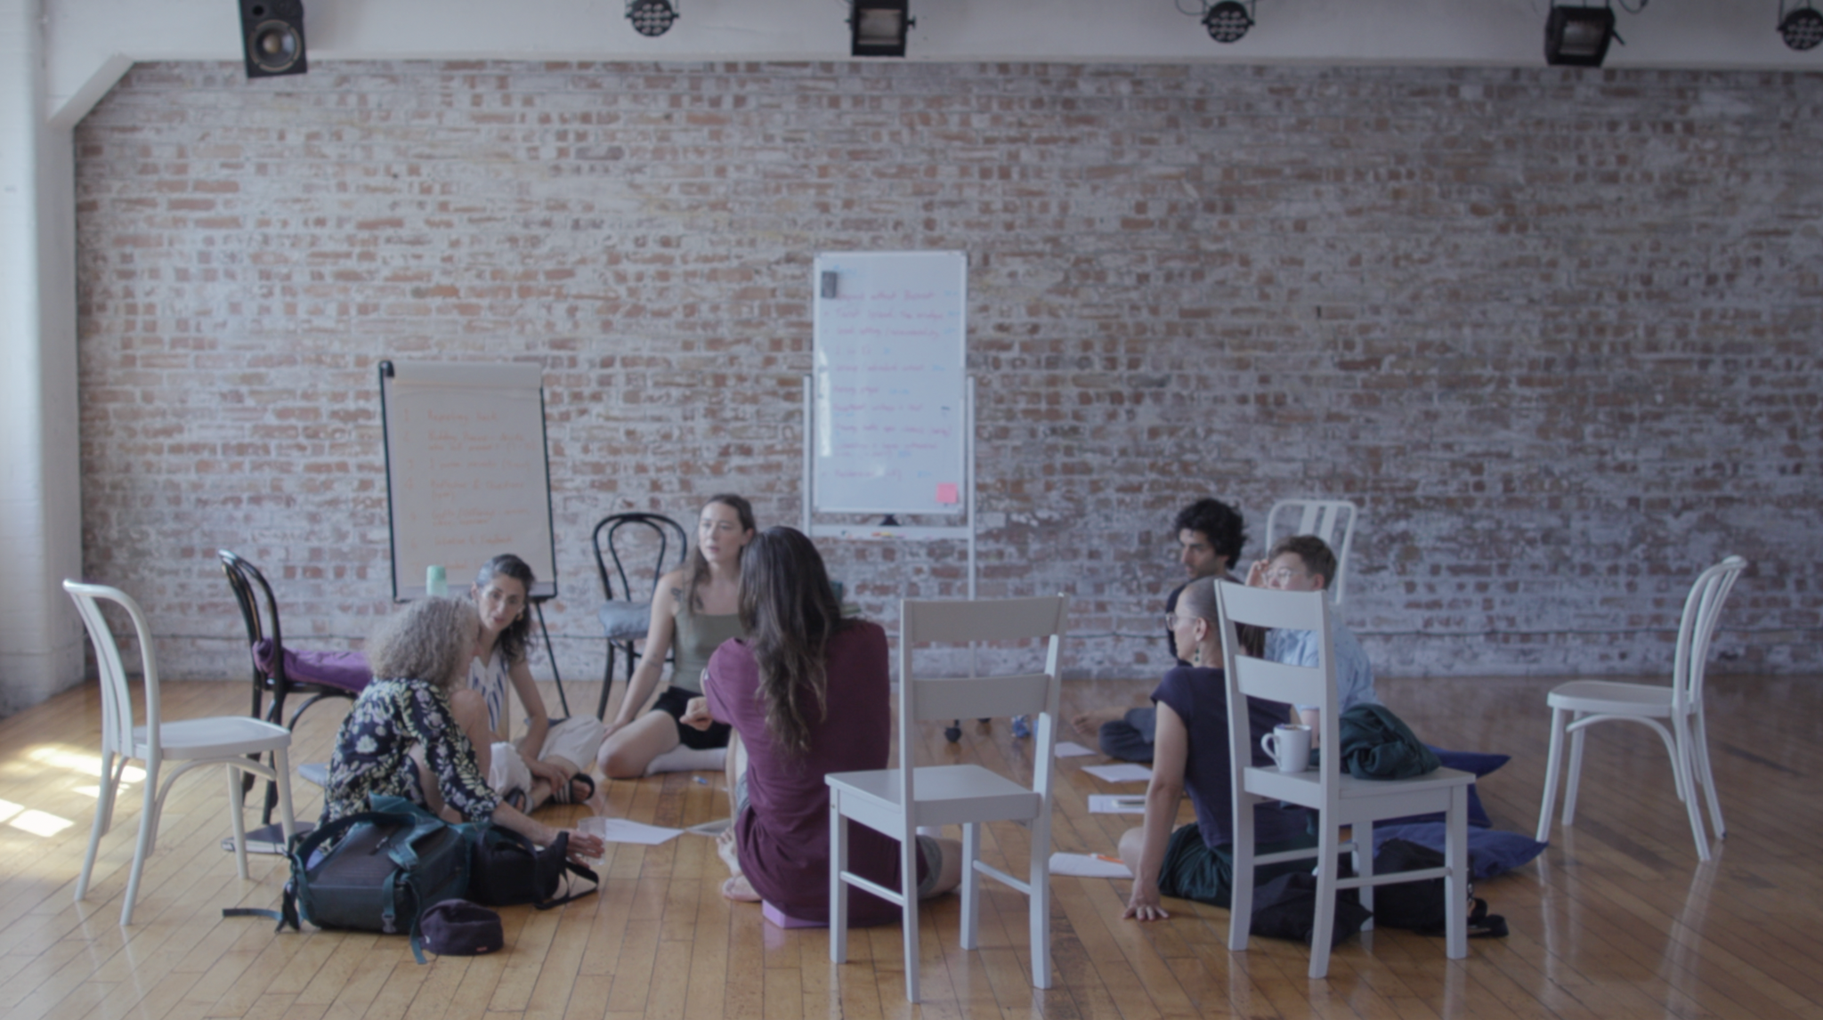
INTERVAL retreat 2025, in partnership with Finnish Institute in UK & Ireland. Photo by Daniel Frampton.
Artist Community, Committee & Our Culture
CDS has re-visioned post-COVID-19, to deepen our commitment to artists. We do this through our Artist Community and Artist Committee initiatives, which work to mitigate the barriers preventing particularly marginalised artists from accessing the peer-support, opportunities, space, and time they need to develop their careers. All of our programmes emerge in response to, and are shaped by these two groups.
The CDS Artist Community: a diverse, non-competitive collective of (currently) 300 artists who guide the organisation’s ethos and programmes, fostering creative autonomy and inclusivity, with a focus on supporting marginalised artists and those lacking institutional support. Artists can take on two roles, Activator or Collaborator, and the majority of our opportunities and resources are prioritised for this group.

Artist Committee: a paid steering group of five mid-career freelance artists from the Artist Community, composed of Global Majority and disabled/neurodivergent members. The Committee collaborates with staff and trustees to guide strategic decisions, develop their leadership skills, and establish a new model of collective governance that compensates artists for their labour, and works to remove barriers to engagement.

CDS, the Artist Community and Committee work in ways that are respectful, transparent, ethical, anti-racist, environmentally conscious, and non-discriminatory. We explore positive change through the lens of the following ideas: collective, autonomy, process, generosity, equity, accountability, and accessibility.

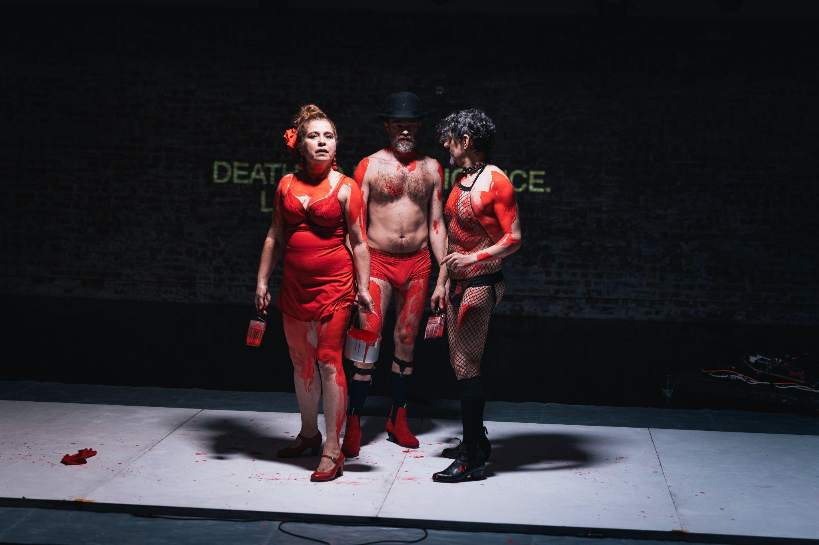

Republica (excerpt)’ by Juan Carlos Otero, Lola Ruedaa & Keir Cooper at Past Works Recycling Plant, January 2026. Photo by Ross Kernahan

The three pillars of the Artist Community are:

Collectivity: We know that artists’ lives are becoming ever-more precarious, and competition over space and resources often feels impossible. The Community is a creative home for artists who need one - a supportive environment to take risks and try things for the first time, and to organise together around critical issues.

Autonomy: We resist the traditional model of ‘artist development’, whereby organisations build programmes for artists, rather than with them. We are a place where artists, staff and trustees work collaboratively to allocate resources, and where artists have autonomy to make things happen and help lead our collective direction of travel.

Equity: We are artists united by a desire to make radical change in the sector and develop anti-ableist, anti-racist, ethical and progressive practices. Our community is driven by an eagerness to decentralise power and redistribute it to those who have historically been excluded.

These three key pillars are also enhanced and underpinned by the following principles:

Process:
We prioritise experimentation and value process over product, embracing DIY, non-traditional practices, and learning through mistakes.

Generosity: We treat each other with respect, kindness, and care, sharing resources and responsibilities while meeting people where they are.

Accountability: We view disagreement and conflict as opportunities for learning, engaging courageously to hold each other accountable with transparency and care.
Accessibility: We are committed to accessibility by addressing the diverse needs of our community, accommodating different learning styles, and working off-site when our building is not inclusive.

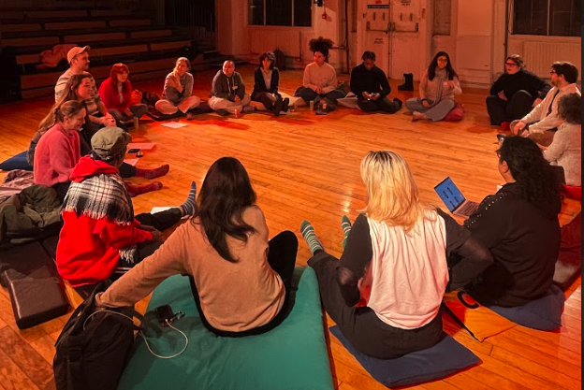
CDS Artist Community Activator Gathering 2025

The Role

Job Title: Artist Community Producer
Contract Type: 0.8 (4 days / 32 hours) part time, 1 year-fixed term contract (with opportunity to extend)
Start Date: To be negotiated, ideally early-May 2026
Salary: £24,000 per annum (£30,000 FTE)
Pension: 3% employers’ contribution
Annual leave: 20 days + statutory bank holidays pro rata. CDS provides all staff members with a separate Christmas break outside this allocation.
Line Manager: Associate Director (with support of Director)

Normal hours/ days of work: The standard working schedule consists of 4 days (32 hours total, including a lunch break) between Monday and Friday, from 10am-6pm, and should include Thursdays. A regular working pattern will be agreed in advance. The business operates seven days a week. When weekend or evening work is required, with prior notice, time off in lieu will be arranged.

Location: To work from our office at Chisenhale Dance Space (64-84 Chisenhale Rd, Bow, London E3 5QZ) with flexible, home working available upon request.
About the Role:
As the Artist Community Producer, you’ll be the key link between CDS and its 300-strong Artist Community, supporting artists to lead, shape and strengthen the organisation’s programme and ethos.
Working within a small but dedicated team, you’ll act as the main point of contact for the Artist Community and Artist Committee — building trusted relationships, leading on the recruitment and onboarding of new artists, and ensuring the community feels informed, connected and empowered at the heart of CDS.
This is a creative and people-centred role, focused on managing & facilitating the Artist Community, enabling artist-led activity and collective leadership to thrive. You’ll design and hold purposeful, accessible spaces that create opportunities for artists to connect with each other and contribute to decision making. This includes organising and facilitating regular Activator Gatherings, coordinating our two annual community assemblies, and shaping agendas and convening monthly Artist Committee meetings. Through these multiple routes, you’ll work collaboratively with the community to conceive, develop and project manage a range of artist-led programmes and initiatives.
Listening will be central to your approach. You’ll create open, empathetic channels for dialogue, actively gather insight from across the community, and translate that learning into clear actions in collaboration with staff members and trustees. As the main facilitator of the CDS Artist Community, you’ll balance advocacy and accountability — ensuring artists’ voices meaningfully inform decision-making while helping the organisation move forward with clarity and cohesion.
You’ll contribute to the ongoing, strategic evolution of our Artist Community and Artist Committee models, as an innovative, collective leadership structure — strengthening governance, transparency and shared responsibility. Central to this will be supporting CDS to continue embedding anti-ableist and anti-racist practice across our programme and wider organisational culture, ensuring equity, access and inclusion are embedded in how we work.
All team members at CDS enjoy flexibility and autonomy to shape their roles in response to both their own practices, and the needs of the organisation and its artists. For this reason, the current team all maintain independent freelance practices alongside their part-time CDS roles — an important element of our artist-led vision and the way we work. This makes the Artist Community Producer role a great opportunity for someone seeking a part-time position that complements and enhances any existing freelance work. They might be a freelance artist or producer looking to bring their skills and passion for activism into an organisational context for the first time; an experienced artist development or community producer seeking a new challenge; or someone with transferable management, organising and facilitation skills who wants to work more directly with artists in a grassroots setting.
We’re looking for someone committed to making active change in the arts, eager to work within an open and collaborative team, and excited to shape the role and the organisation by bringing bold new ideas and approaches to supporting the Artist Community.
The Artist Community Producer will report to the Associate Director (the previous Artist Community Producer role holder) and work closely with the Venue & Events Producer and Marketing & Communications Producer. The whole team is led and supported by the Director, with the Artist Community Producer contributing across the following areas as directed:

Artist Community Leadership, Facilitation, and Management
- Act as the primary point of contact for the Artist Community, building trusted, reciprocal relationships and supporting artists to actively shape and lead CDS’s programmes and ethos.
- Lead the planning and facilitation of all Artist Community gatherings, including bi-monthly Activator Gatherings and two annual community-wide assemblies.
- Sustain and deepen an efficient, inclusive, and equitable artist-led leadership structure in collaboration with the Artist Community, Artist Committee, staff and trustees.
- Create practical ways for artists to meaningfully shape CDS programmes, ensuring feedback and insight are translated into clear actions and responsive organisational development.
- Be responsible for data management for the CDS Artist Community, including integrating online forms and surveys with our CRM, and updating artist profiles on our public-facing website.
- Produce and edit the monthly Chisenmail newsletter, sharing relevant opportunities, updates and the practices of the Artist Community.
- Facilitate and manage internal communication and information channels with the community (including the Artist Community WhatsApp and Intranet Homepage, on Notion.)

Artist Committee Management
- Lead the planning and facilitation of monthly Artist Committee meetings, in collaboration with its members.
- Act as the main point of contact and pastoral support for the five Artist Committee members.
- Meet monthly with the Artist Committee Conduit - an artist on the committee who takes on more responsibility for helping shape meeting agendas, and sits in on Board of Trustee meetings.
- Manage the annual recruitment and onboarding process for the Artist Committee, ensuring transparency and accessibility.

Programme Development & Delivery
- Work with the staff team, Artist Committee and wider Artist Community to conceive, develop and project-manage new artist-led initiatives — including a new annual event Making Sh*t Happen - a summer building takeover, showcasing the practices of the Artist Community to the public.
- In collaboration with the Director and Associate Director, build and maintain relationships with external partners to support programme development, sector engagement, and artist resourcing initiatives.
- Contribute to budget planning and management for Artist Community activity and artistic programmes.

Artist Support
- Provide one-to-one guidance and professional support to artists through monthly “Arts Counselling” sessions, supporting career development, collaboration and access to opportunities.

Advocacy & Organisational Contribution
- Support CDS to embed anti-ableist and anti-racist practice across programmes and organisational culture.
- Contribute to the continued evolution of CDS as an artist-led organisation, embedding innovative, inclusive and sustainable leadership practices.
- Work collaboratively across the team, contributing to organisational priorities and wider initiatives as required.
- Represent CDS locally, regionally and nationally in relation to its artistic programme and community practice.
—
Person Specification
Essential
- Experience working in an arts, education, or community-focused organisation, or in a comparable environment.
- Experience facilitating and/or managing outreach, community, or participatory arts projects.
- Interest in, or experience with, contemporary dance, performance, and/or other art forms, and a desire to engage with the work of artists in our community.
- Knowledge of the needs of dance and performance artists, and the challenges they face.
- Excellent communication skills, both verbal and written, with the ability to relate to and build relationships with a wide range of people.
- Strong organisational and administrative skills with the ability to manage multiple projects and priorities.
- Strong teamwork skills and the ability to work effectively within a small team.
- A commitment to equity, inclusion, and anti-oppressive practices.
Desirable
- Significant experience and confidence as a facilitator.
- Experience working with CRM data management systems, and online platforms such as Mailchimp, Notion, and Wordpress.
- Experience in fundraising from a range of sources.
- Experience managing budgets and financial planning for projects or programmes.
- Familiarity with the social and cultural landscape of Bow, East London, or similar communities.
- Experience working within collective leadership structures.
You do not have to have done this exact job before or tick all the criteria. We’re looking for someone with enthusiasm and tenacity, a commitment to creating a space where artists can thrive and the ability to step into an exciting role in a small team. We also offer training, mentorship and developmental support to all CDS staff.

Please send the following to Executive Director reece@chisenhaledancespace.co.uk by the deadline below:
● CV, with two referee contacts (only contacted if offered role)
● No more than 2 A4 page covering letter OR a 5-minute video telling us why you’re the right person for this role
● Please complete the equality and diversity monitoring form by clicking here.
Interview Process
We encourage applications from those who are under-represented in our organisation and marginalised in our sector and society, especially those from the global majority, including those of African diaspora heritage, South Asian, East Asian, South-East Asian heritage, mixed heritage. Applicants from one of the above under-represented groups who can demonstrate they meet all the essential criteria will be prioritised for interview.
We want our interview process to be open and friendly. We don't want to add pressure onto what already can be a stressful situation, so we will send interviewees our questions and the names of the panel members in advance of the interview to better reflect our working environment. We’ll invite you to the building for a tour and to meet the team. If you have any access needs for the interview, we will meet them.
Accessibility
Our imperfect home for the past 45 years has been on the second floor of a warehouse building, accessed by a staircase only. We regret that we cannot currently adequately support wheelchair users and those for whom stairs are a barrier. We are working towards a redevelopment on our site that would create lift-access and are the early-stages of a several-years-long process. We will offer individual feedback to all unsuccessful candidates only if requested.

Key Dates

Applications Open: 6 March 2026
Deadline: 2 April 2026, midnight
Shortlisted applicants informed: by end of 7 April 2026
Interviews: 10 April 2026
(in person preference, online option available if required for travel or access reasons, please let us know availability)
Start date: Ideally early May 2026, though exact date is negotiable.

If you have questions about this opportunity, informal conversations prior to application can be arranged with Director, Reece McMahon. Please contact reece@chisenhaledancespace.co.uk to arrange.
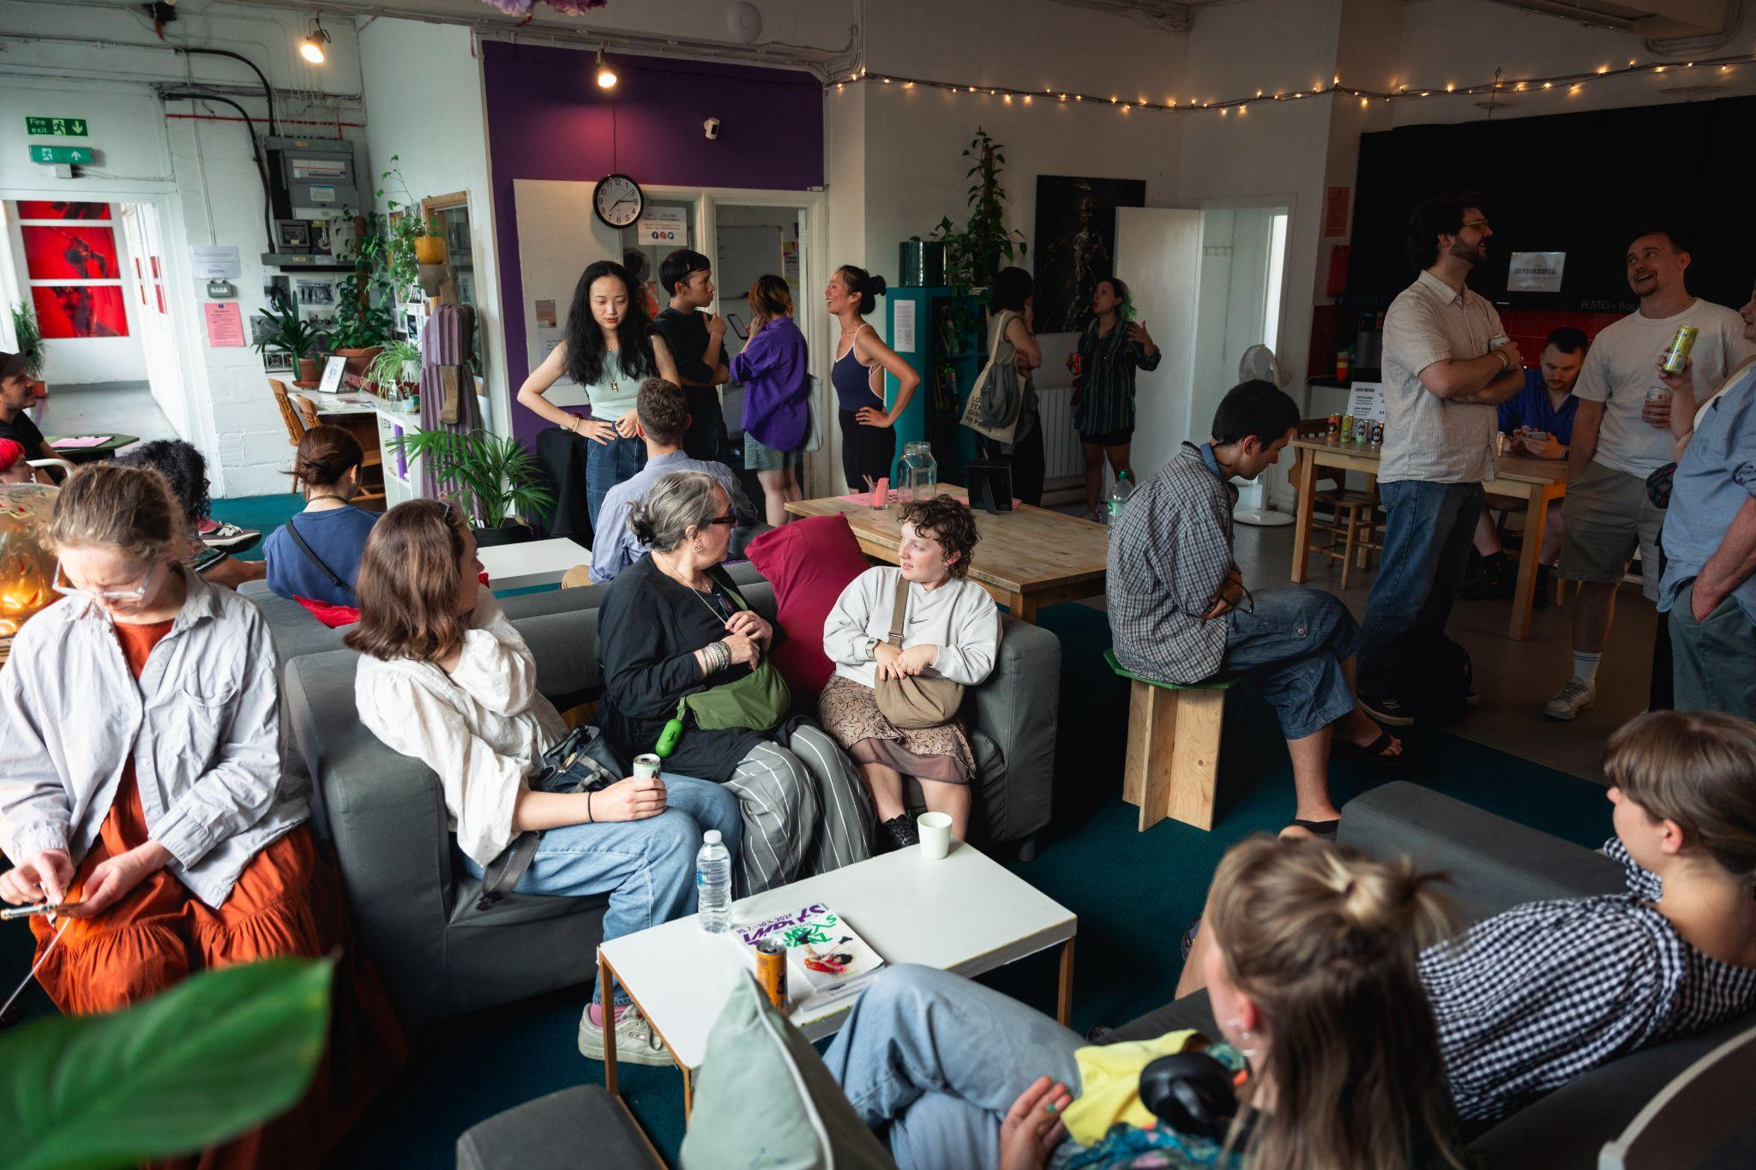
Audience at Mind The Gap, part of Scratch Renaissance. Photo Ross Kernahan.

